Course title: System Analysis and Design

Project title: American hotel register

Group number: Project team 10

Name of group members: Tabitha Maru

Date completed: July 28th,2020

Introduction
American hotel Register is a 150 year old hospitality firm that is a manufacturer and supplier of hospitality products and services and is its head office is in Vernon Hills, Illinois. (“American hotel Register,” n.d.). This company used ERP system to run the daily functionalities, with digital overturns in the market and competitors adapting new technologies and systems made it necessary to look for a new system. Hiring a new employee to tackle system Analysis is a step in the new direction. Launching a new system called SAP S/4HANA which moved from blueprint to a live system which put simply means delivering real time reports and some predictive analytics to improve functionality. The purpose of this project is to look into the old system and the new system , how they work together, the issues that arose and how to deal with them as well as new systems that should be viable or work better.
Evaluation of the Information System Requirements
American hotel register is a global hospitality supplier that prides itself in creating memorable guest experiences. It is family owned based in the US the industries it works on is hotel, healthcare, government, education and funeral. The company has many employees and a lot of products around 70000 which provides a lot of data. The original design had a thoughtful selection of KPIs in a tile-based layout. The limitations were big such as having the same KPIs making it difficult to different areas of the business, the issues were redundant and unnecessary data, using colors that do not match up the products, the design didn’t offer interactivity to the user which in this case is the hotels, the data has no context with the company. Acquiring new customers is affected using this system is difficult considering its not interactivity, and the colors are not helping.
The new implementation is better and different, it touched every aspect of the enterprise which is more innovative and provides a better experience for customers. Building a data integration process, spot gaps, build out an IT leadership team to develop strategic roadmap.
The farm being market leader in hospitality this meant they were doing something that works but with the competitive markets its hard to maintain that. Evolution is important to make this better having a system that reports real time data this means data is saved every time it is entered, using analytics such as predictive this generates value to customers. Having a collaborative approach which brings together CFO and CIO has helped make the transition from the old system to the new system. This new system focuses on what’s relevant this means that keywords and proper headings are used to provide relevant information to the customers , easier analysis this is done by adding variance calculations which clearly shows positive negative and breakeven, cleaner aesthetic this is in terms of color and the look, collaborative comments this allows customers to leave reviews and comments which helps prospective customers and answer existing customers questions.
The products and services offered by this customer are American Funeral Supply, American HealthCare Supply, American Government Supply, American Education Supply, Canadian Hotel Supply Company, International Hotel Supply Company, aBundle, these services need data
keeping records and constantly updating helps and makes it easier to weed out products that do not work as well improve those golden products. The new system integrates all parts this system reduces the time spent on looking for information, With digitization on the rise check in hotels is almost all a hundred percent this reduces the number of inquiries directly to these businesses saving time. A good interactive system fosters this.
structured approach
functional decomposition diagram (FDD)

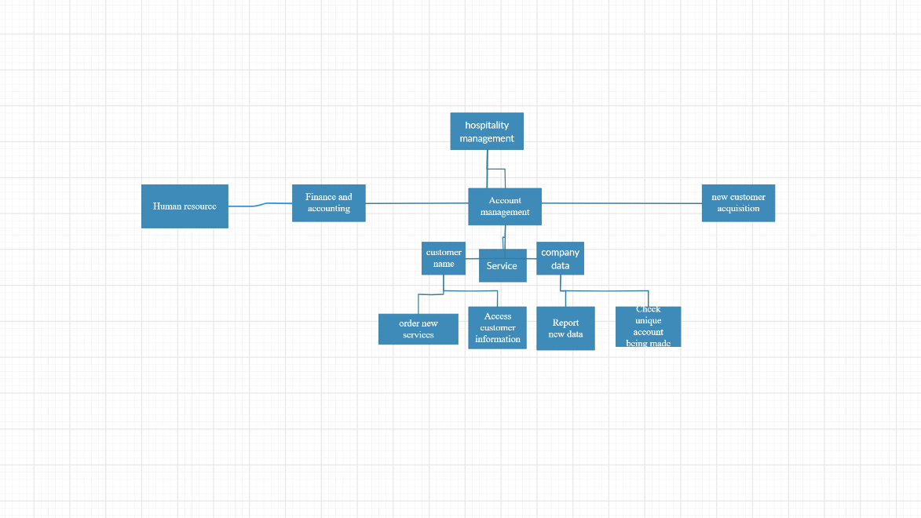

Context diagram

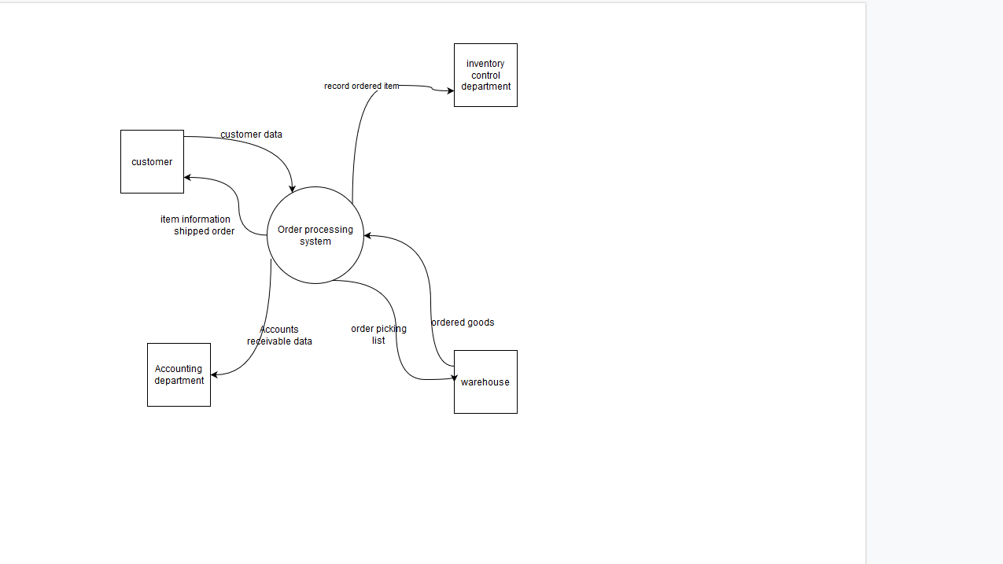

Diagram 0 data flow diagram (DFD)

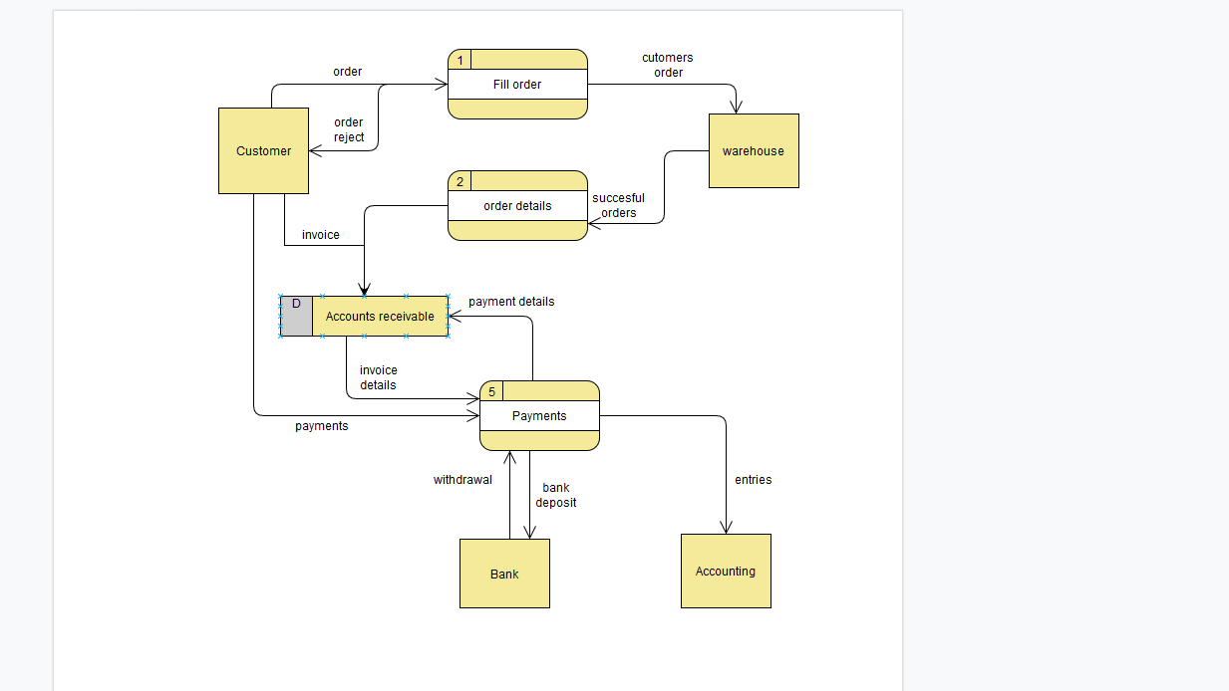

Evaluation of Alternative Vendor Solutions
Service system design
Service system design taxonomy came from customer service encounter and contact touchpoints of various service personnel along with thoughtful and detailed consideration of behind the scene service production processes. The blueprinting process or structural operational components associated with service system design can be useful in assisting hotel operators with the necessary insights required to ensure both direct and indirect customer contact points align with customer expectations (Wemmerlov, 1990). This system has two main components, Labor intensity(this involves higher costs in terms of time effort and overall costs for the people working there) and cocreation(this depends the way customers interacts with the people in charge of them and the level of personalization they require). The core of this system is the degree which customers interact with personnel to complete the services. This has now been linked to multiservice interfaces in areas that require customers such banking. People generally prefer higher quality services so offering that works better than the old-fashioned system.
Artificial intelligence (AI)
AI refers to the performance of seemingly intelligent behaviours by computers or machines. It is used in hospitality because of its ability to carry out traditionally human functions at any time of the day. This means the company saves money, time and reduce human errors.
AI has many advantages such as answering guest questions on hotel premises such as the Germany robot Sepp, Hotel surveillance with security cameras instead of the traditional people, More personalized search results this is made easy by Search engine optimization, travellers or customers can now use chatbots to help with regular conversations and to ask for further instructions. This system however has a few disadvantages these include but not limited to AI is still developing, there is a data privacy issues as it can be easily hacked. Some AI are also difficult to control and run this together with expensive makes it harder to come by for now.
Augmented reality
Augmented reality (AR) is an interactive experience of a real-world environment where the objects that reside in the real world are enhanced by computer-generated perceptual information, sometimes across multiple sensory modalities,including visual, auditory, haptic, somatosensory and olfactory(“Augmented Reality” n.d.). In hotel managements it allows hotels and other related fields to enhance the physical environment they are selling or the experience of exploring surrounding areas. The other factor is guests do not need to ask many questions anymore are AR shows all the information everyday anytime.
The advantages of AR are interactive hotel rooms, Gamification and Augmented hotel environments.
The disadvantages are it is expensive to buy and maintain as well as not very secure.
In conclusion Artificial intelligence is a better choice. This is considering AI includes most of these systems. Considering this is mostly a supplier and a manufacturer the human personnel required is prone to human error which would affect the company were there to be errors. Augment reality can be integrated in AI as well as Big data to help with inventory, customer orders as well a personal information. With encryption and a better IT employees security is greatly improved.
Implementation of the Chosen Solution
Google cloud platform is the recommended company for all these factors of Artificial intelligence and big data, as much as there are other companies with almost the same services such as Amazon web services Google is still more trusted and has more services. Using one company for all AI services is cheaper easy to maintain. Cloud based hosting as well as getting the hardware required for other AI systems like robots and self service kiosks. Although kiosks and robots come last in the implementation of this system its still important in these company.
Cloud based systems such as data storage and VPNs which help with security reasons for this outline is good.
Parallel operation is the type of system changeover to be used as the old system is still functional but still operational this means direct cutover is not as good. This is also due to Artificial intelligence being a new system for all the companies. The employees also need time to be familiarize themselves with the system, Applying this system requires a lot of time and is expensive to build and implement, experimental systems like pilot operation mostly makes sense for companies that have no money problems or those that are cheap to implement. Having a phased operation is not efficient as the old system is almost completely different from the new system.
Parallel operation helps with competitive advantage as well as making sure the old data is slowly implemented and carefully saved in the cloud. With google Analytics and big data, customers are likely to get more refined and closer to what the customers require. This reduces the work the company does on marketing and data security.
Systems such as analysis of the data is handled by google the company does less work, this is cheaper and safer as google is a big company which has enough resources to be slightly safer as well cheaper than hiring a new IT manager to build a database and software that check data so the employees can analyze. This helps to reduce human errors as well as make it faster to do the normal work.
The user documentation to be implemented is an app for self service, FAQS and tutorials, now days people have a less concentration gradient so tutorials are better than written manuals which are usually wordy and tedious to go through. The new system should be cheaper than the alternatives, faster than the old systems, more user friendly.
Conclusion
This project was a success, there was a lot of lessons form how to do research on businesses.
Hospitality business is changing fast this is especially important considering the pandemic going on right now. Most people will want work from home. Having A VPN is important for a company as well as accessing data form the cloud instead of the old fashioned system that included bulky files which were difficult to update, locate arrange as well as keep data safe, they could be easily stolen, destroyed or altered in case of a fire the whole company will be ruined in this scenario. The type of system changeover is really important for implementing new systems , finding the correct one helps save money and time which is especially life changing for companies, most businesses no matter how ethical they are they require profit maximization before they help people or provide services this is excluding NGOs and government resources.
System Analysis is important in determining the systems that are required for business. This tells us how to correctly use AI and IoT to make work easier and to automate tedious repetitive jobs like data entry and sorting. As much people are scared that they will lose jobs they should be aware that there are jobs such as robotics engineers that were not there in the past. New jobs will be created and the tedious jobs will be automated. This is especially important considering things happen such as a global pandemic that requires people to work remotely.
Most services will be made online that were mostly in person this includes restaurants, they will not need servers and waitresses as the can now order with a touch of a button. Psychotherapists and teachers can now work with skype or other visual services. People should not be afraid of AI taking over the world as humans evolve and make machines to counter machines for example encryption machines have decryption machines, neutralizing bot uses. Businesses should upgrade to Information technology.
List of References
American Hotel Register Company. (n.d.). In Wikipedia. Retrieved July 28, 2020, from
https://en.wikipedia.org/wiki/American_Hotel_Register_Company
Extreme Dashboard Makeover: American Hotel Register. (2018, November 13). Retrieved July 25, 2020, from https://www.sapanalytics.cloud/resources-extreme-dashboard-makeover-american-hotel-register/
How Augmented reality is transforming the hospitality industry. (n.d). In revfine. Retrieved July 27, 2020https://www.revfine.com/augmented-reality-hospitality-industry/

(Donald Fomby, September 18, 2019). How to use Artificial Intelligence in the Hospitality Industry in Revfine
https://www.hotel-online.com/press_releases/release/ai-in-the-hospitality-industry-pros-and-cons/
Agrawal, A., Gans, J., Goldfarb, A. (2018). Prediction Machines: The Simple Economics of Artificial Intelligence. Harvard Business Review Press, 2-3.
Yorks, L. (2008). What We Know, What We Don’t Know, What We Need to Know-Integrative literature reviews are research. Human Resource Development Review (7) 2, 139-141.
Davenport, Thomas H. The AI Advantage: How to put the artificial intelligence revolution to work (Cambridge, MA: The MIT Press, 2018), 10.
Neuhofer, B., Buhalis, D., Ladkin, A. (2012). Conceptualizing Technology Enhanced Destinations. Journal of Destination Marketing (1) 2, 36-46.

